

ECONOMICS

Practice SAC 2.1.1-

UNIT 2 - OUTCOME 2

You will have 80 minutes to complete this task.

The SAC is a Structured Questions Test

The total SAC is worth 10% of your Unit 1 grade.

Conditions and restrictions
- Students are permitted to bring into the room for this task: pens, pencils, highlighters, erasers, sharpeners and rulers
- Students are NOT permitted to bring into the room for this task: blank sheets of paper and/or white out liquid/tape.

Materials supplied
- Question and answer book of 15 pages

Instructions
- Print your name in the space provided on the top of the front page.
- All written responses must be in English.

Student name ____________________________________________

Grade/Score: ____/___40 Satisfactory Completion? S/N: ______
(Provisional)
--------------------------------------------------------------------------------------
Assessment Criteria
This assessment task was developed using the Outcome 1 key knowledge and skills in Unit 2 VCE Economics:
Key knowledge

• the nature and meaning of trade-offs in economics
• aggregate demand and its components
• aggregate supply
• the meaning and measurement of economic growth using real Gross Domestic Product (GDP) and real GDP per capita
• the economic benefits of economic growth such as growth in material living standards, employment opportunities, economic development and non-material living standards
• the limitations associated with using GDP per capita to measure changes in living standards
• aggregate demand and aggregate supply factors that may influence economic growth
• factors that might affect future rates of economic growth such as an ageing population and labour force participation
• the meaning of both long-term economic prosperity and environmental sustainability
• economic and environmental costs of economic growth such as climate change, depletion of natural resources and deterioration of common access resources
• trade-offs and compatibility between economic growth and environmental sustainability
• alternative economic indicators of living standards
• the effect of policy response used to address environmental effects of economic growth such as market-based approaches, direct actions and regulation.

Key skills
• define key economic concepts and terms and use them appropriately
• access and synthesise information gathered from a range of sources and draw conclusions
• identify trends, patterns, similarities and differences in economic data and other information
• gather, interpret and analyse statistical and graphical data
• evaluate the potential costs and benefits associated with economic activity.

SECTION A – Multiple Choice
Instructions for Section A
Answer all questions.
Choose the response that is correct or that best answers the question.
A correct answer scores 1, an incorrect answer scores 0.
A mark will not be awarded if more than one response is chosen for a question.

Question 1
The level of economic activity refers to:
- All production and expenditure by businesses
- Any activity by individuals, businesses and government that generates production, income, employment and expenditure
- Consumption and expenditure on goods and services by households
- The activities of the government in the economy

Question 2
Which of the following is not used as an indicator of changes in non-material living standards?
- The crime rate
- The level of greenhouse gas emissions
- The quantity of goods and services a person is able to purchase
- The rate of urban sprawl

Question 3
Which of the following aggregate supply factors would tend to slow down economic activity?
- A reduction in interest rates on business loans and overdrafts
- A fall in the real unit labour costs
- A rise in the cost of imported raw materials used by local businesses
- A rise in the participation rate

Question 4
The government’s goal of strong and sustainable economic growth is a rate around 3 – 3.5% per annum. This is considered to be an appropriate level of growth in order to avoid all of the following except:
- Rising levels of unemployment
- Increased levels of spending by households
- Jeopardising future living standards
- Depletion of environmental resources

Question 5
Which of the following factors is likely to have an effect on Consumption Expenditure (C) which is different from that of the other three factors?
- An increase in the savings ratio
- A decrease in the rates of personal income tax
- A decrease in the level of consumer confidence
- An increase in the level of unemployment
SECTION B – Written responses
Instructions for Section B
Answer all questions in the spaces provided.

Question 1 (6 marks)
a. Explain one economic cost and one environmental cost associated with unsustainable economic growth.
4 marks

b. Describe the trade-off between economic growth and environmental sustainability.
2 marks

Question 2 (4 marks)
Explain one direct and one market-based policy response used by the government to address the environmental effects of economic growth.

Question 3 (5 marks)
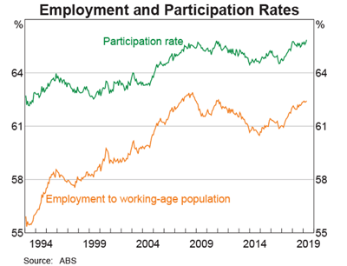

a. Describe the trend in Australia’s Labour Force Participation Rate over the past two years.
2 marks

b. Explain how the trend in the Labour Force Participation Rate is likely to influence the aggregate supply curve and future rates of economic growth.
3 marks

Question 4 (8 marks)
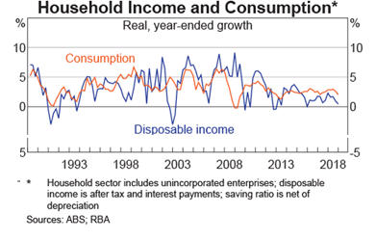
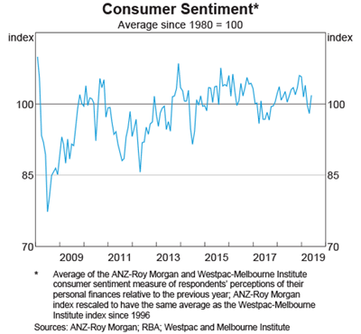
Analyse how the trend in both disposable income and consumer confidence is likely to influence the Aggregate Demand curve and:
- Economic growth
- Employment opportunities
- Living standards

Question 5 (6 marks)
The table below includes the chain volume of goods and services for Nation H over 2018 and 2019:
 | 2018 | 2019
Chain volume of goods and services | 100 | 103

a. Calculate the change in Real Gross Domestic Product over 2018 and 2019.
1 mark

b. Explain one economic benefit of economic growth.
2 marks

d. Explain the impact of an improvement in economic growth on economic development and living standards.
3 marks

Question 6 (6 marks)
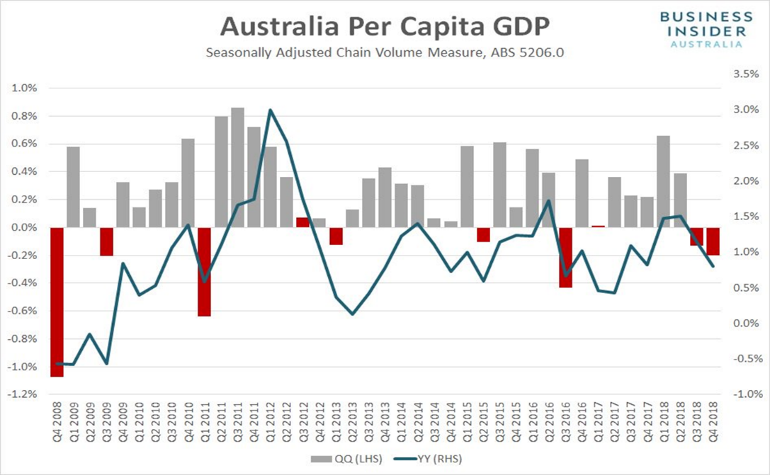
“Officially the two consecutive quarters of negative growth means that Australia has officially entered a GDP per capita recession”

a. Explain one reason that has influence the trend movement of Australia’s GDP per capita and the impact on material living standards.
2 marks

b. Explain one limitation of using real GDP per capita to measure living standards.
2 marks

d. Explain one alternative economic indicator to measure living standards.
2 marks

Extra writing space
(clearly label all responses)

